**Commercial satellites**

Sai Hareesha Tirumala.

Executive Summary: -

The project aims towards creation of a database for commercial satellites, to understand their business model, Operations Model, Revenue Model. We try to understand and perform operations on few of the questions that we to understand about their business, we aim towards concentrating the operations towards the top satellite companies of the United states

We also want to understand the operations pattern towards where their sales are operated from and to, we try to concentrate on the aspects of understanding where the sales has been more and which has been the most optimum, a performance based analysis in the form of operations help us find out these aspects

Lastly we try to understand the revenue model as in which client has been profitable , which model has been profitable and which region has been profitable in terms of total revenue earned by the company.

Project background: -

*These days we can see there are many uses from commercial satellites. Satellite services composes the largest share of the commercial space market, and includes communications, broadband internet, direct-to-home television, radio, and imaging/mapping services.

*“Over the past five years, record numbers of satellites have been deployed, costs to manufacture and launch have decreased while utility has increased – all leading to increased affordability, productivity and new markets. Despite all these new benefits, we must not forget that only the satellite industry can deliver truly ubiquitous, high quality, reliable and often critical emergency space-based services that consumer, government and enterprise customers demand both at home and around the world.”

*Many companies and countries are getting profited with these commercial satellites so in our project we are going look at these satellites, uses, companies, profits in our project.

ER Diagram: -

Tables: -

1.states

6.Business_client

7)Order_info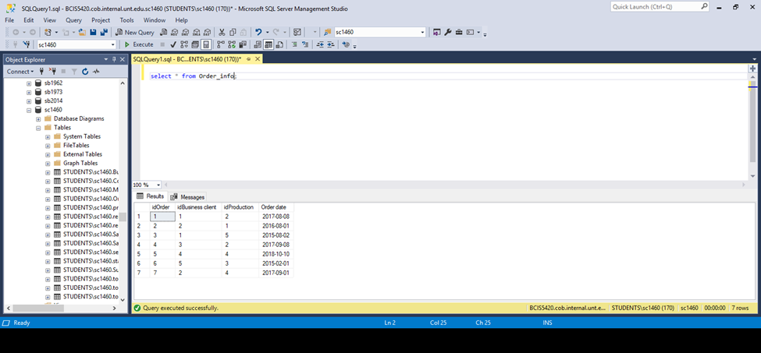

8)Service_details

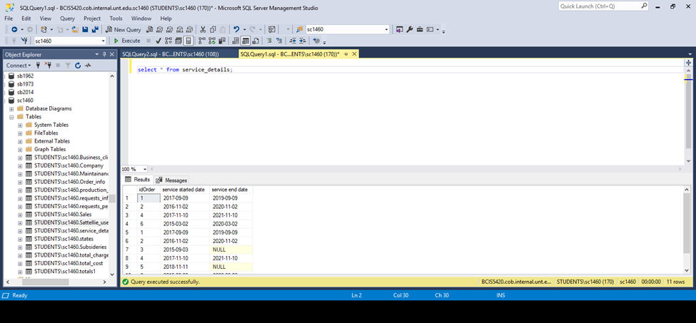

9)Maintanence_info

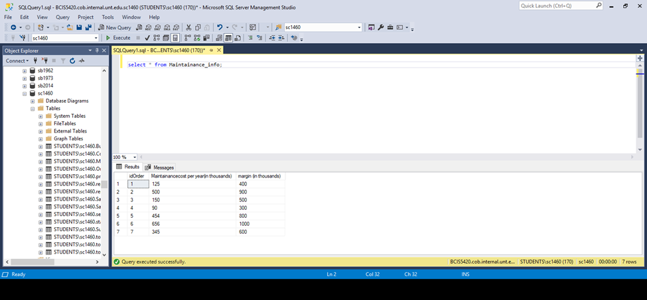

10)Requests_info

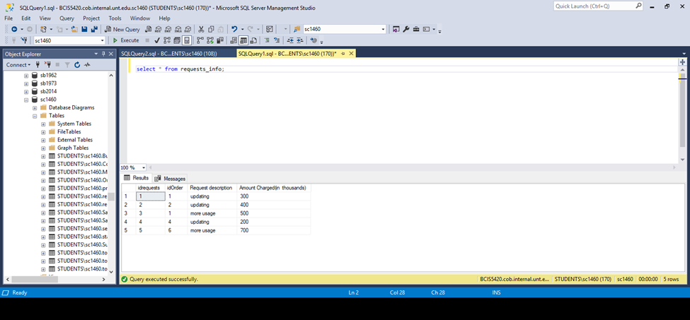

Queries: -

1) Q. display the continent and country of all the companies that have subsidiaries ?

Qureey-Select * from states, Subsideries where states.state=Subsideries.State

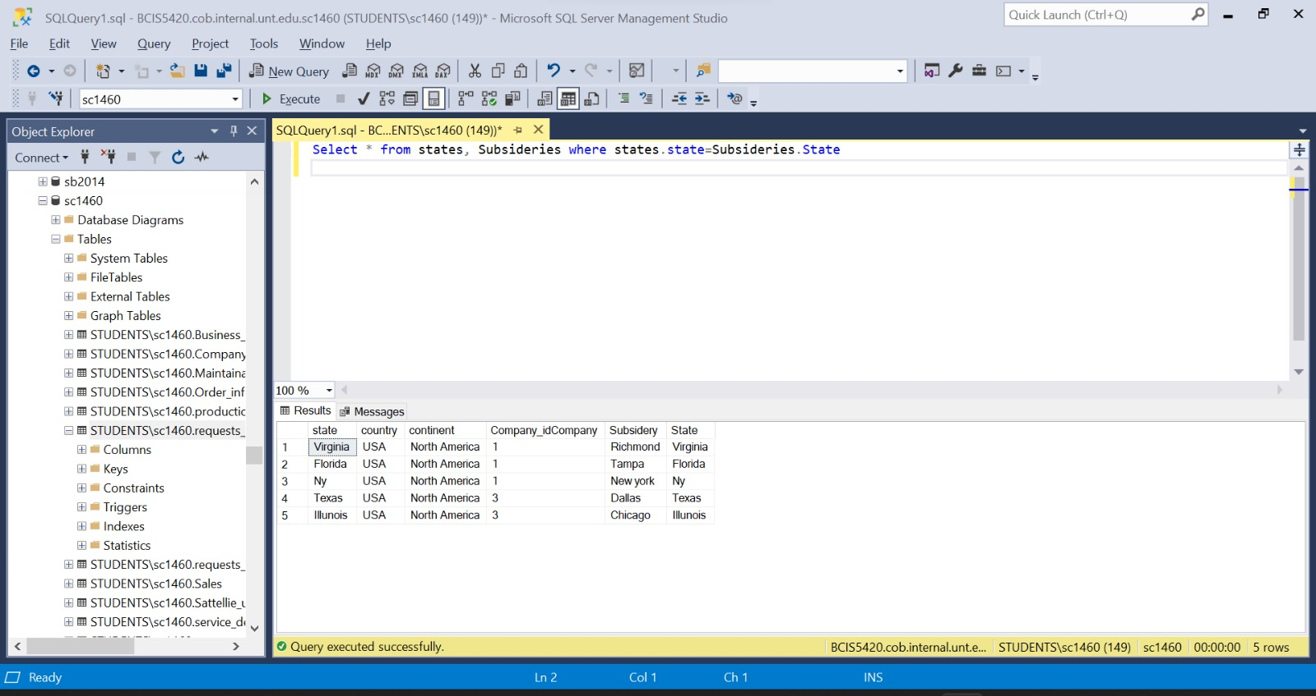

Comments:- we are trying to display the country band continents of the companies that have subsidiaries in terms to see the countries that have allowed companies to have subsidiaries

2)Looking up clients who have ordered:-

Querie: select [client name],[order date],idorder from Business_client,Order_info where Business_client.[idBusiness client]=Order_info.[idBusiness client]; -

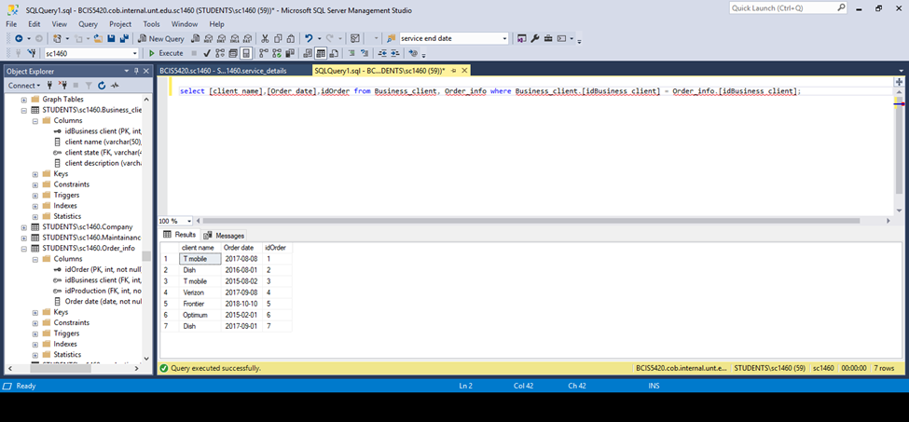

Comment: - we are trying to understand and callout the clients that have made an order for satellites in past 3 years

3)Looking up for clients who made requests

Querie: -select [client name],[Order date],Order_info.idorder,[Request description] from Business_client,Order_info,requests_info where Business_client.[idBusiness client]=Order_info.[idBusiness client]and requests_info.idOrder=Order_info.idOrder;

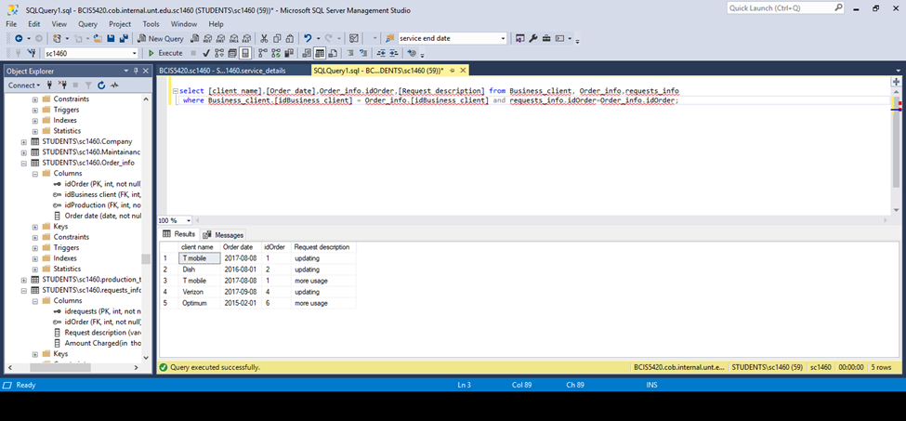

Comment:- we are trying to call out all those clients that have made a request and also read what their request was

4)Looking up for id’s of production whose margin is greater than or equal to 100 million

Querie: -select idProduction as [Production id],[Margin(in million)]from Sales,Order_info where [Margin(in million)]>=100 and Order_info.idOrder=Sales.idOrder;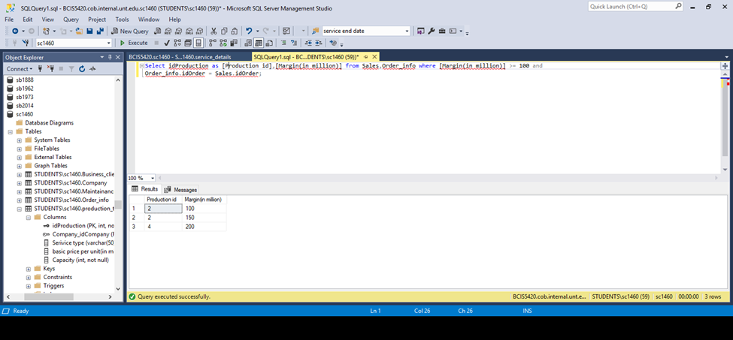

Comment: - we are trying to call out the production ID of those where the Margin in million has been greater than or equal to 100

5)Looking up company’s headquarters continent

Querie: -select [name] as [Company name],[Headquarters state],continent from Company inner join states on Company.[Headquarters state]=states.[state];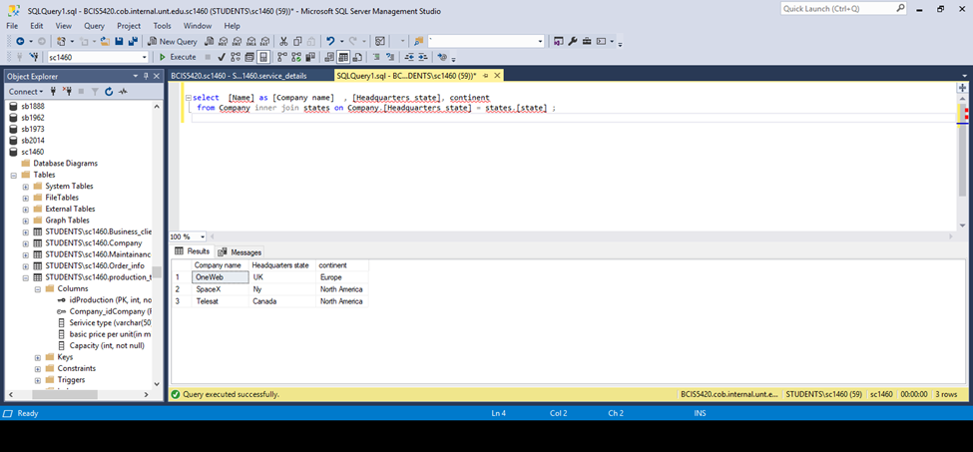

Comment: - We are trying to find the continent in which each company’s headquarter lies using the tables company and states

6)Looking up for company id’s who provide multiple services

Querie: -select Company_idCompany as [company id],count(Company_idCompany) as [services] from Production_table Inner join Company ON Production_table.Company_idCompany=Company.idCompany group by Company_idCompany having count(Company_idCompany)>1

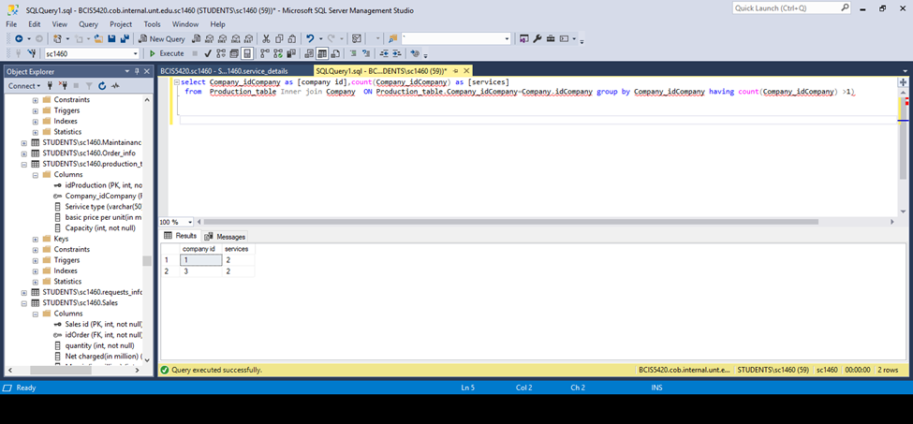

Comment: - We are trying to find those companies that are rendering more than 1 service overall

7)Displaying total cost for each year including maintenance cost.

Querie: -select[idBusiness client],iif(year([service end date]) is null,2022-year([service started date]), year([service end date]),year([service end date])-year([service started date]))as[number of years],[Maintainancecost per year(in thousands)]*iif(year([service end data]) is null,2022-year([service started date]),year([service end date])-year([service started date])) as [total maintanance cost],[net charged(in million)]*1000+[Maintainancecost per year(inthousands)]*iif(year([service end date]) is null,2022-year([service started date]),year([service end date])-year([service started date]))as[total cost in thousand]into total_costfrom Order_info,Maintainance_info,service_details,Saleswhere Order_info.idOrder=Maintainance_info.idOrder and Order_info.idOrder=service_details.idOrder and Order_info.idOrder=Sales.idOrder;

select * from total_cost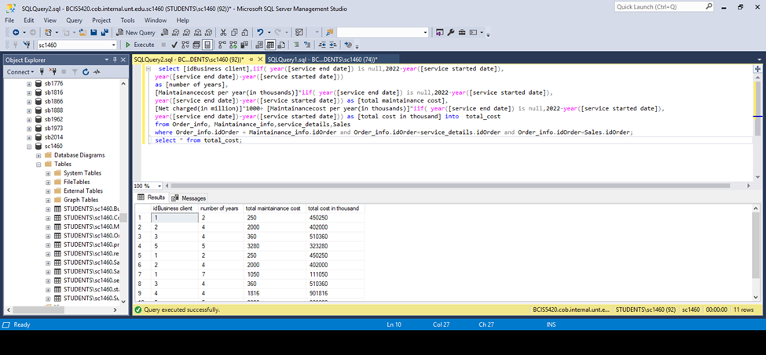

Comment: - We are looking forward to find the total cost clubbed along with maintenance cost which help usunderstand the objective of the total cost incurred each year

8)Grouping above results by clientid and storing in another table totals1

Querie: -select [idBusiness client],sum([total cost in thousand])as[total cost]into totals1 from total_cost group by [idBusiness client];

select * from totals1;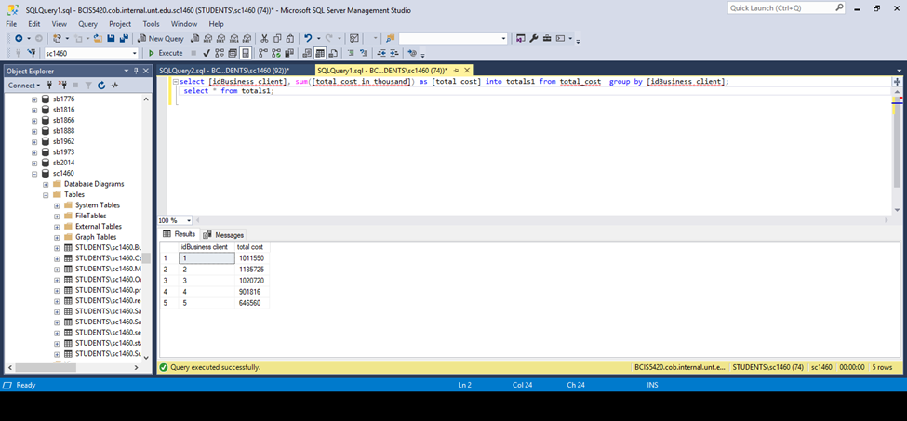

Comment: - we are trying find the total cost that has been incurred by a business client while considering the Business id as the priority.

9)Grouping the request charges per order and storing in table create table requests_per_order

Querie: -select idOrder,sum([Amount Charged(in thousand)]) as [sum of charges for each other]into requests_per_order from requests_info goup by idorder;

select * from requests_per_order;

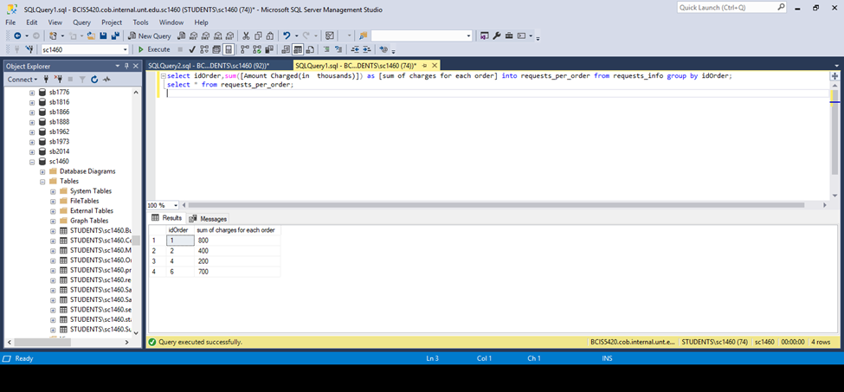

Comment:- - we are trying to find the total charge that has been levied by each company on an order by SUM (ing) the charges in the tables

10)Displaying total cost including request charges for each clientid

Querie: -select [idBusiness client],

iif([idBusiness client] in (select idOrder from request_per_order),[total cost]+

[sum of charges for rach order],[total cost]) as [total cost in thousand including request charges]into total_charges_including_requestcharge from totals1

left join requests_per_order

on totals1.[idBusiness client]=requests_per_order.idOrder;

select* from total_charges_including_requestcharge;

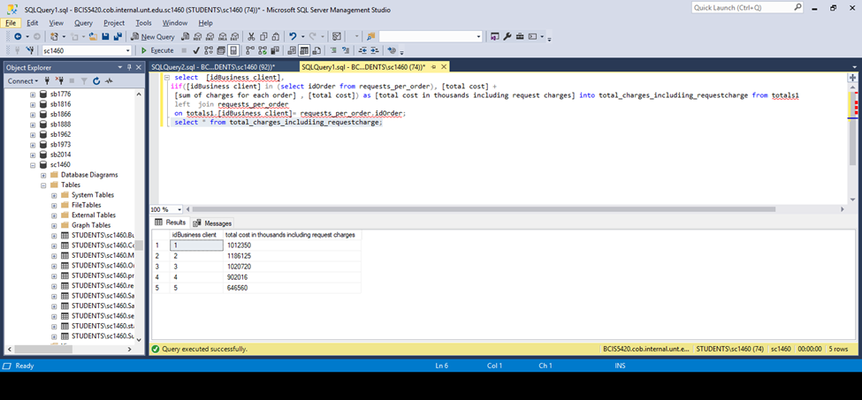

Comment:- We are trying to understand the total cost along with the charge that has been levied by each request for the Clients ordered by the Business ID’s

11)Displaying client name along with the total charges spend by them

Querie: select [client name],[total cost in thousand including request charges] from Business_client

inner join total_charges_including_requestcharge

on Business_client.[idBusiness client]=total_charges_including_requestcharge.[idBusiness client]; -

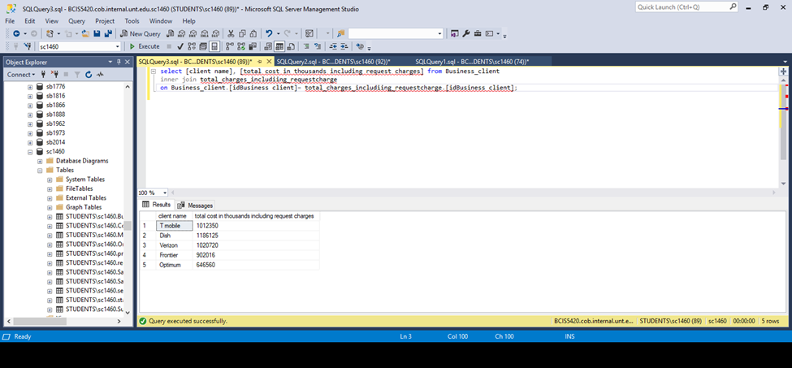

Comment: - We are trying to understand the total cost along with the charge that has been levied by each request for the Clients ordered by the Business ID’s

12)Displaying margin for maintenance and margin for ordering for each order.

Querie: -select Maintainance_info.idOrder,[Margin(in thousands)] as [maintainance per year in Thousands],

[Margin(in million)]from Maintainance_info,Sales where Maintainance_info.idOrder=Sales.idOrder;

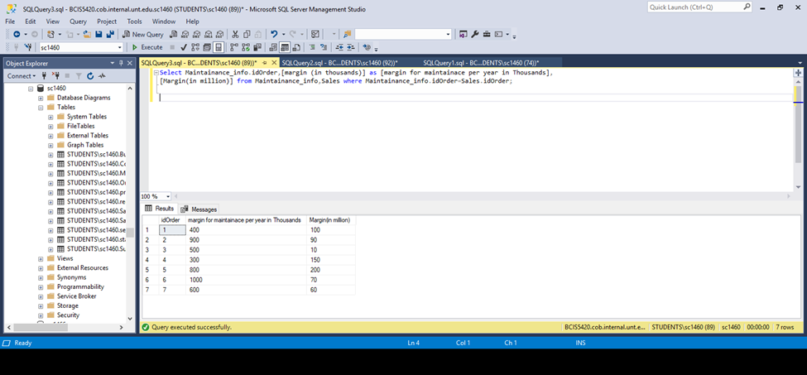

Comment: - we are trying to find the margin of maintance along with that understand the margin of ordering

13)Displaying the month, the service ended

Querie: -select [client name],service_details.idOrder,month([service end date]) as [service end month] from service_details,Business_client,Order_info where service_details.idOrder=Order_info.idOrder and Business_client.[idBusiness client]=Order_info.[idBusiness client];

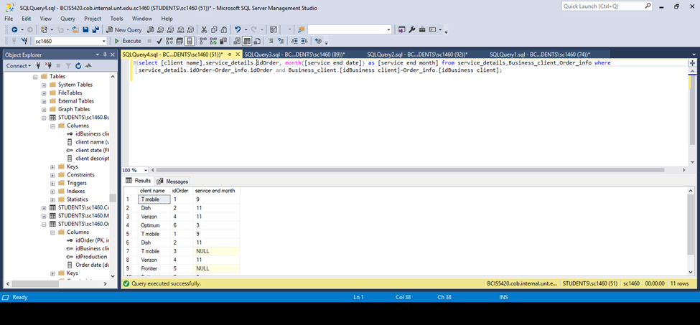

Comment: - We are trying to understand the year and month the service was terminated to check and understand the months/ years each client had rendered service to

14)Displaying details of companies who have subsidiaries

Querie : -select * from Company,Subsiders where Company.idCompany=Subsiders.Company_idCompany;

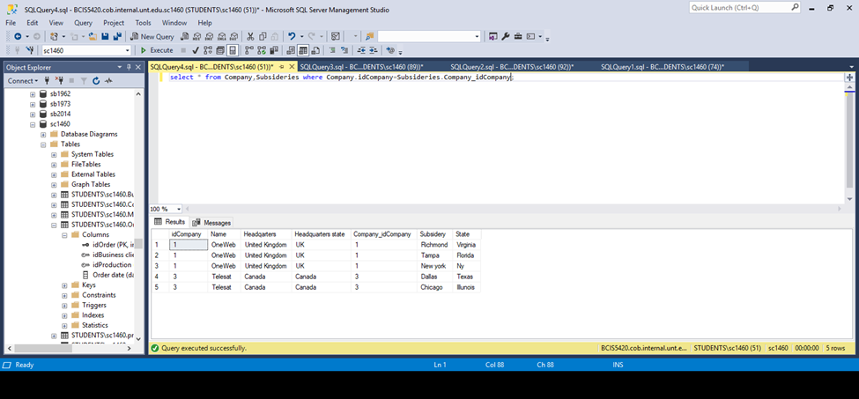

Comment: -- we are trying to understand the companies that have subsidiaries using the tables company and subsidiaries.

15)Displaying companies who provide fixed services

Querie: -select * from Company,Production_table where Company.idCompany=Production_table.Company_idCompany and [Service type]='fixed';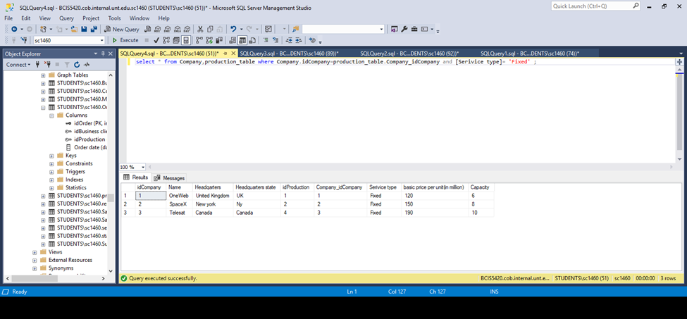

Comment: -- we are trying to find the companies who have been attended in terms of service by using the key word fixed in the operation

16)Displaying product details whose capacity> 5 and used or televisions

Querie:- select * from production_table,Sattellie_uses where production=idProduction and Capacity>5 and usage='television';

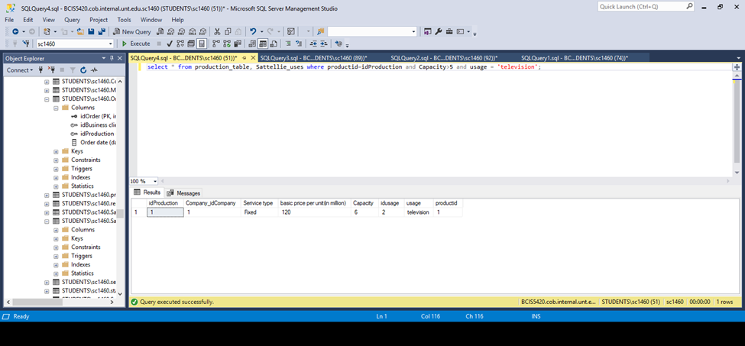

Comment:- We are trying to pin point a usage called television where the capacity has been greater than 5 and has the same productionid and Id Production

17)Displaying clients whose ordered in 2017 and 2018

Querie: -select * from Business_client,Order_info where Order_info.[idBusiness client]=Business_client.[idBusiness client] and year(Order_info.[Order date]) in (2017,2018);

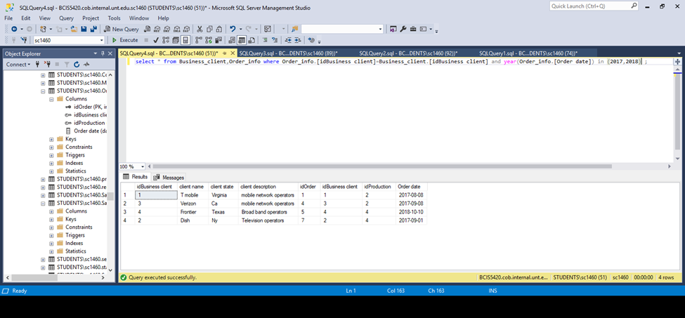

Comment: - we are trying to display client name, client description and business client and production

18)Displaying clients who are in headquarters state of any company

Querie: -select [client name],[client state],country,continent from Business_client,states where states.state=Business_client.[client state] and [client state] in (select [Headquarters state] from company);

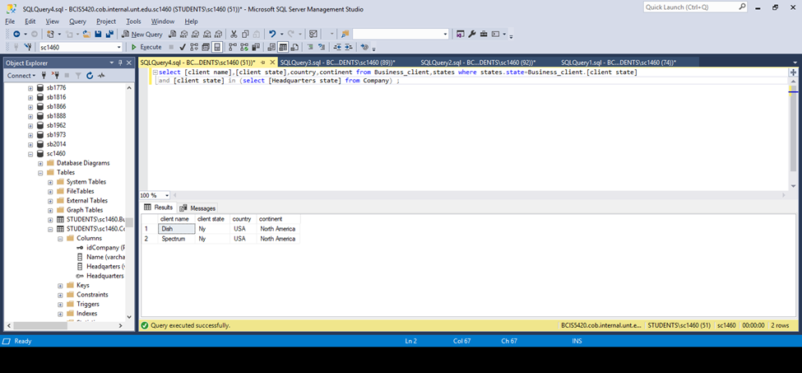

Comment: -- we are trying to find if there is any client in the same region as there is a company headquater

19)Displaying clients who ordered more than 2 units

Querie: -select * from Business_client,Order_info,Sales where Order_info.[idBussiness client]=Business_client.[idBussiness client]

And Sales.idOrder_info.idorder and quantity>2;

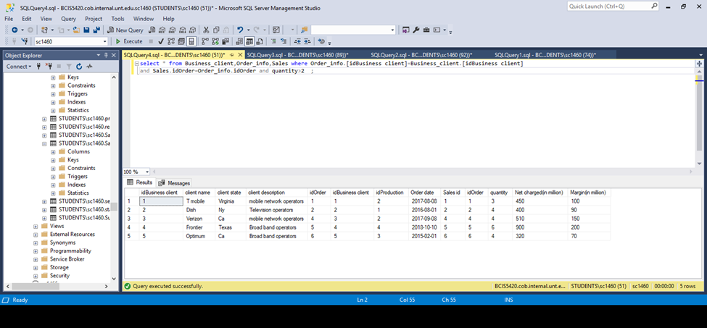

Comment: -- we are trying to find the clients who have ordered more than 2 satellites along with their uses and description.

20)Displaying clients who spent more than 1 Billion

Querie: -select [client name],[total cost in thousands including request charges] from total_charges_including_requestcharge, Business_client

Where total_charges_including_requestcharge.[idBussiness client] =Business_client.[idBussiness client] and [total cost in thousands including request charges]> 1000000;

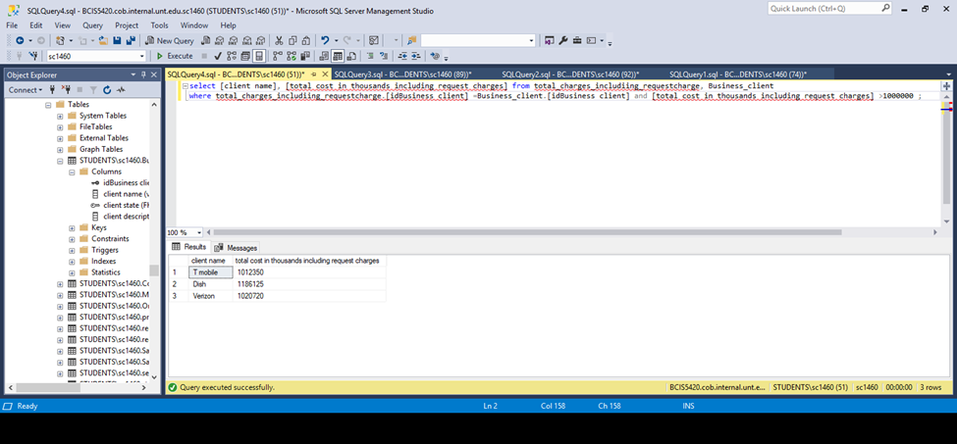

Comment: - We are trying to Display the client who has spent more than 1 Billion in the past year

CONCLUSION:-

The Ideology that we have tried to replicate is that if the commercial satellite industry had a database what would have been our areas of interest in the terms of questions and query’s

We have tried to involve and combat issues that have arrived in terms of service and maintenance requests

The understanding and involvement in-terms of region and country with respect to headquarters, profits, sales and Requests.